PRACTICAL 8

AIM: Configuration of Router

1. Booting up of the device (Note: we are using puTTy software)

* Here as mentioned in manual we can practically see the configuration in puTTy and also in cisco packet tracer

Memory has been initialized here

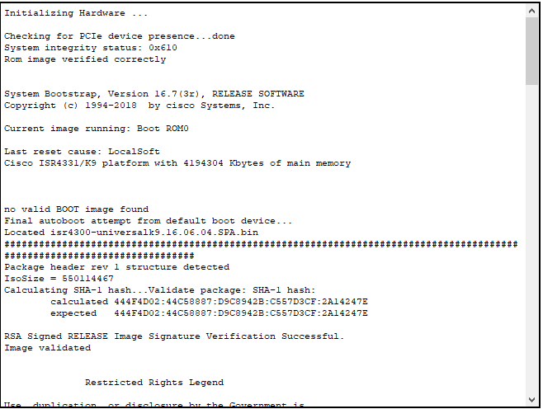

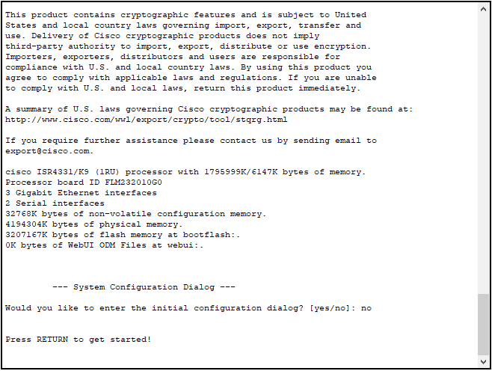

1. Entering the CLI

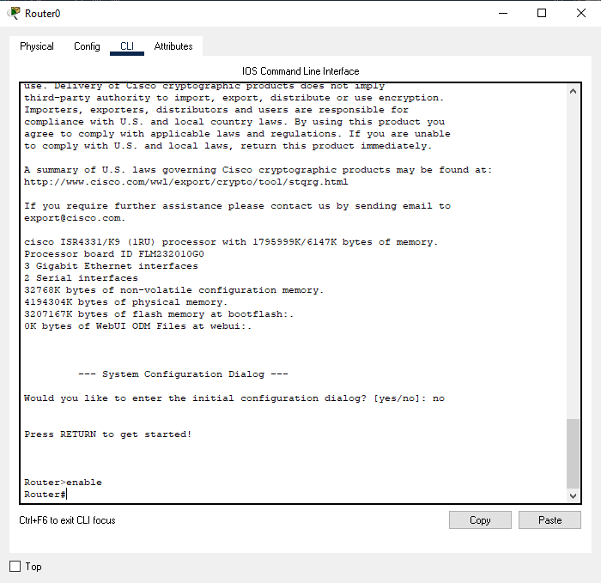

1. Configuring Hostname

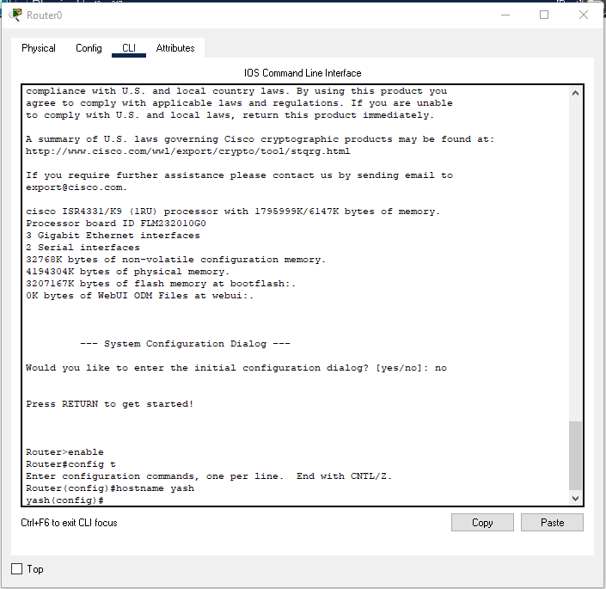

1. Configure the privileged mode and secret passwords.

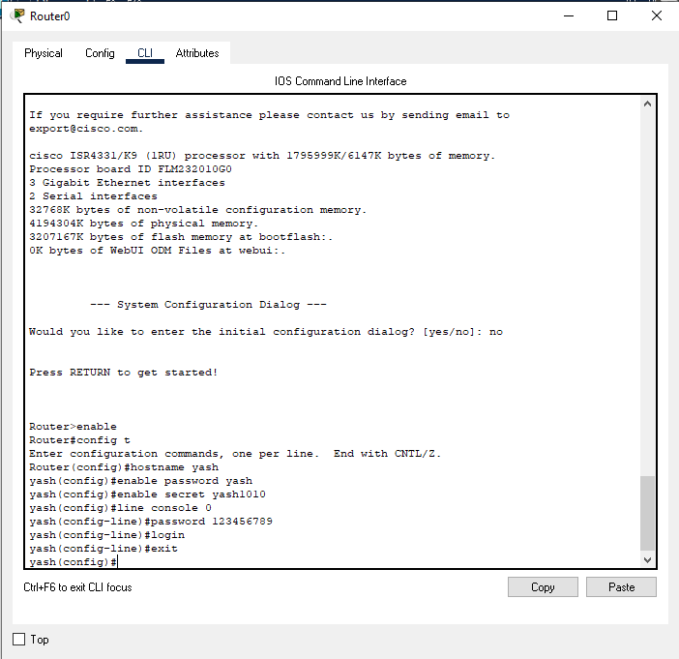

1. Configure the console password.



1. Configure the vty password to allow Telnet access to the router.

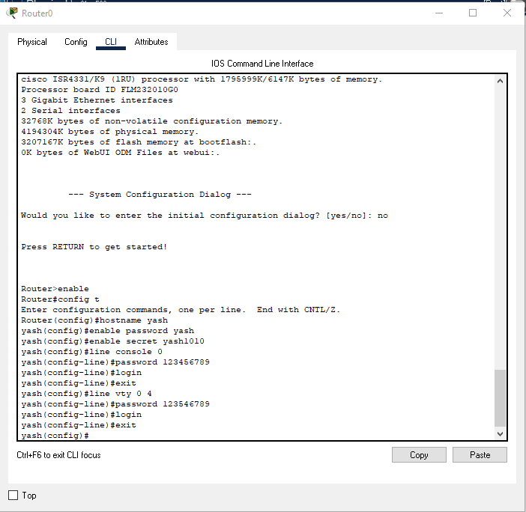

1. Configure password encryption, a MOTD banner, and turn off domain server lookup.

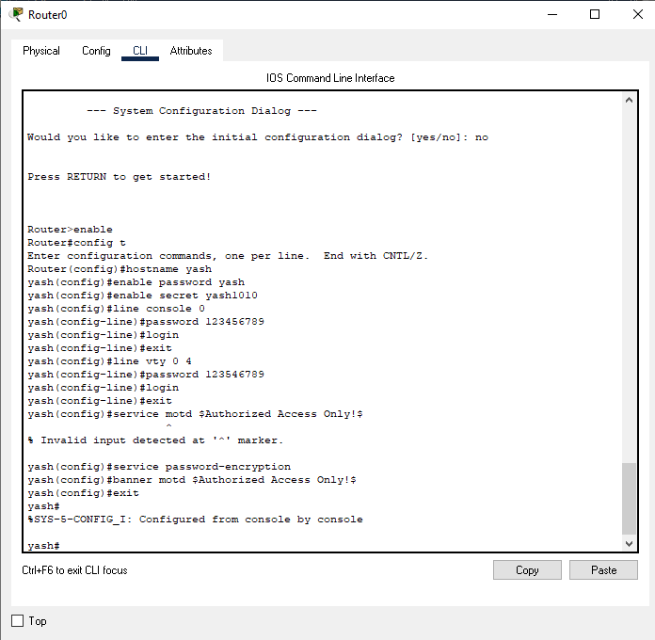

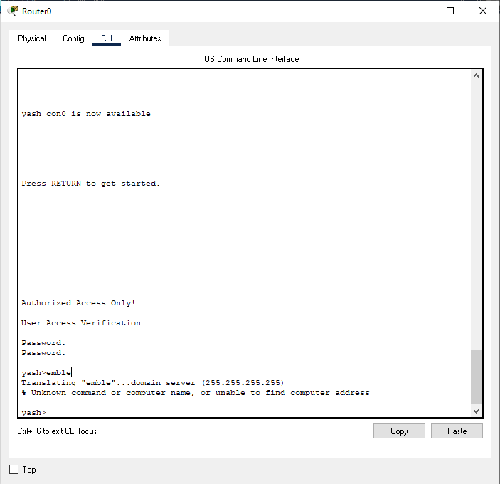

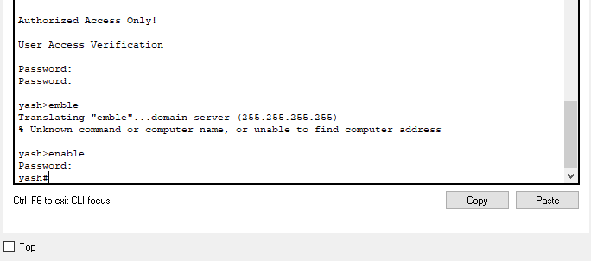

1. Check the version of the router

Show version is used to see the detailed version of router

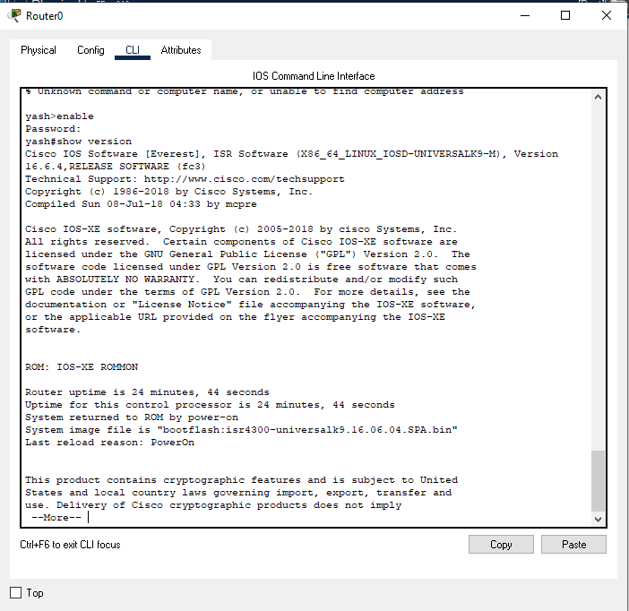

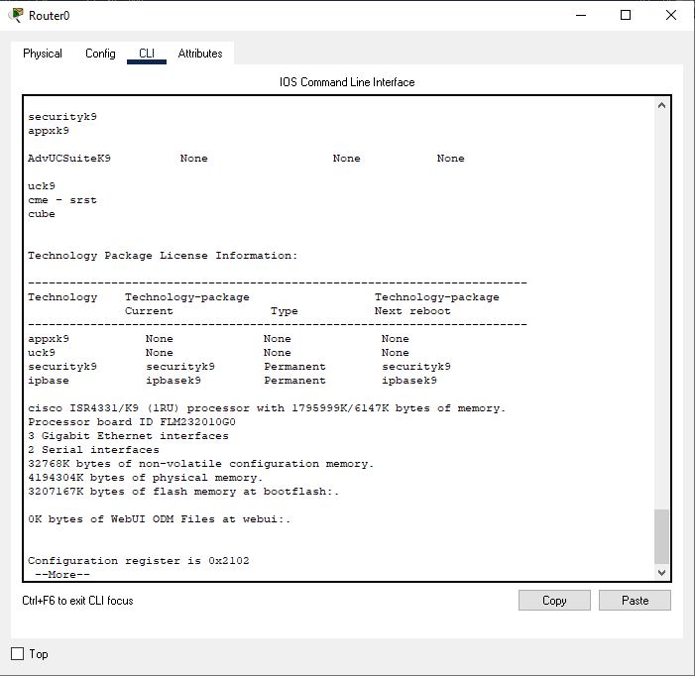

11. to check currently working configuration of router show running-config

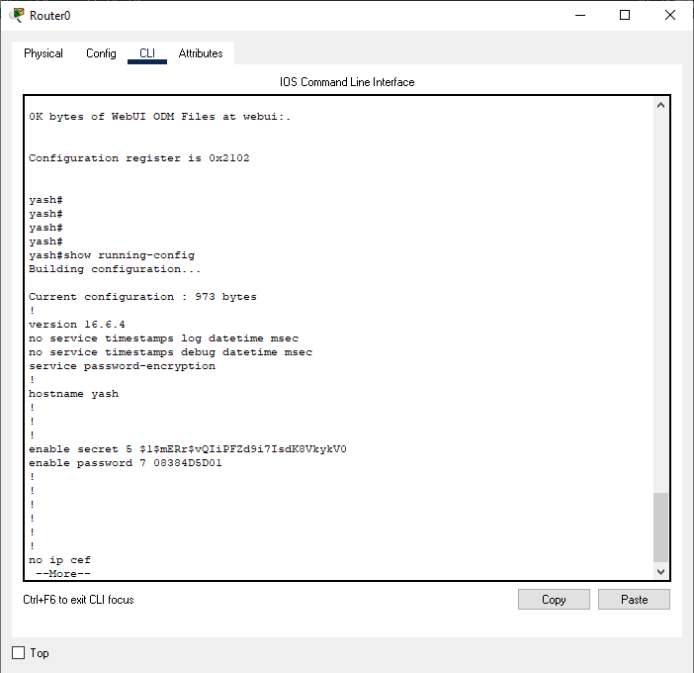

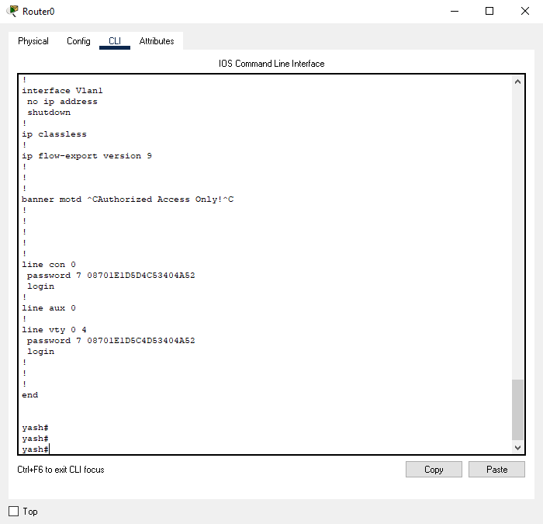

11 next step is to Configure the interface interface GigabitEthernet0/0/0

and similarly 0/0/1 but I haven’t configured ip address to second interface 1 and give( ip address 192.168.100.1 255.255.255.0) to give ip

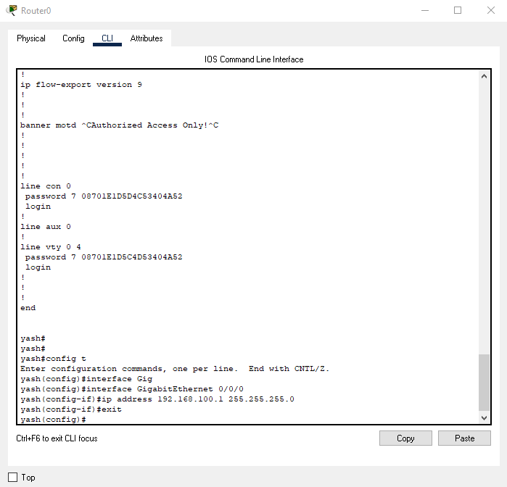

1. check configuration with(show ip configuration brief and check that only 0/0/0 link has ip address manually and unsigned for second interface

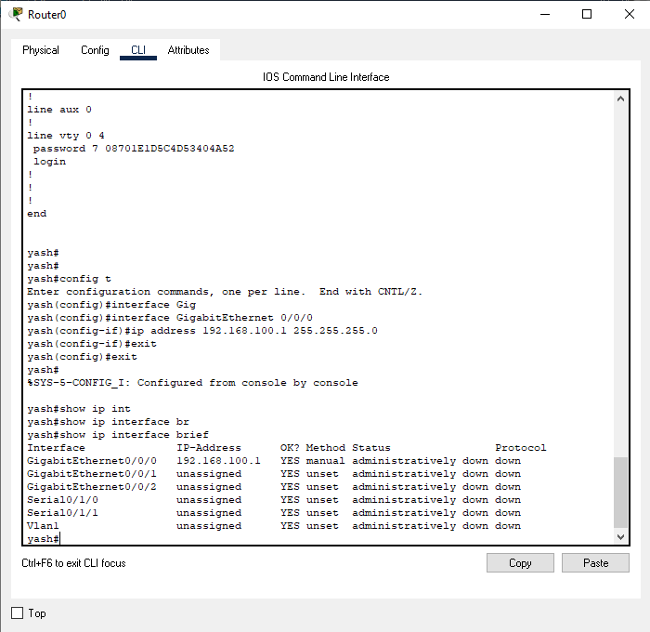

1. The most important command is write memory to save configuration on real router

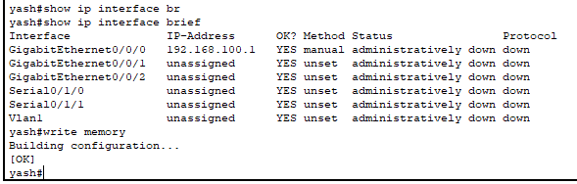

1. to check history(show history)

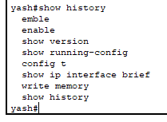

1. to erase the configuration it is used first when u want to configure router to reset

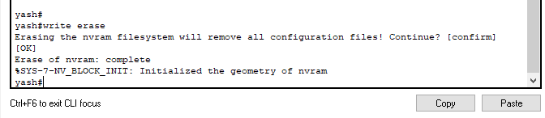

* + Bringing up an interface

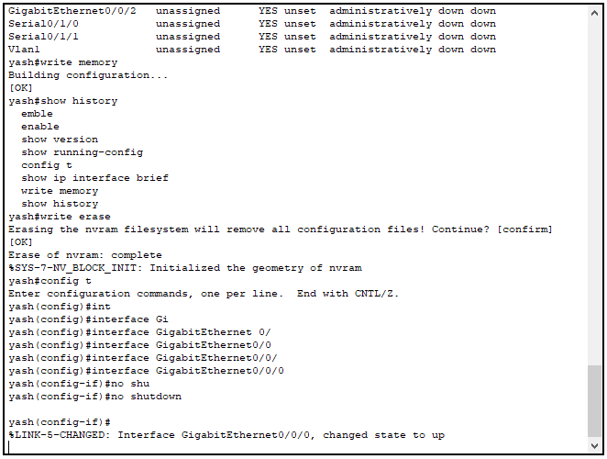

1. to check routing show ip route

And to add static routing (ip route network ip subnet mask next hop)

